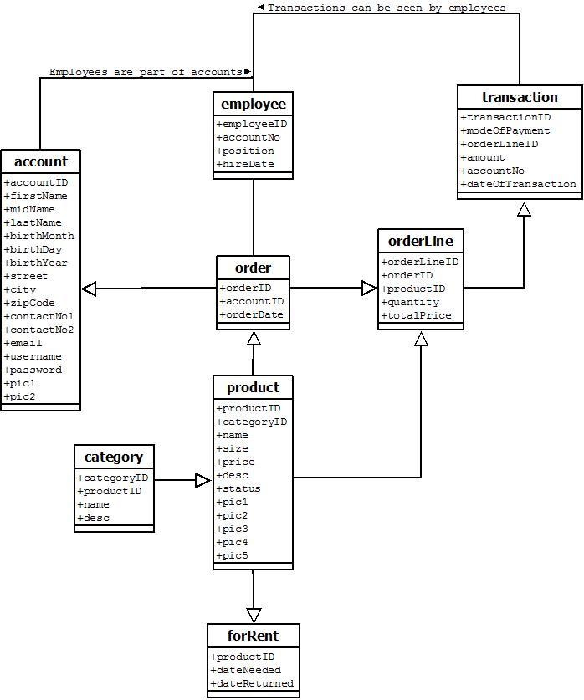

product has no connection to order

what is the connection of employee and order?

is employee supposed to be a subclass of account?

does the account have subclasses like master account, employee, client, etc.? since the employee has an account as well with other purposes

please add a short description of the ERD to make it more understandable.

product -> forRent <- orderLine

^forRent should be in the middle of product and orderLine forRent has it’s own rentID

orderline inherits rentID rather than productID

^It’s because you should not make weak entities if it does not connect to more than 1 entity and it seems to make more sense to show that the rent is connected to the order rather than a stand alone entity.

*Technical stuff (just for formality):*

Please name the relations for most of the classes.

Cardinalities in Relationships.

Indicate primary keys, please :)